**The National Institute of Engineering**



(An Autonomous Institution affiliated under

Visvesvaraya Technological University, Belagavi)

Manandawadi Road, Mysuru – 570008

# OLD AGE HOME ACTIVITY

**“Visit to Sanidhya Oldage Home, Mysuru”**

*As a partial fulfillment for the award of Degree in Electrical & Electronics Engineering*

**A public service activity for the award of activity points organized by**

## SANIDHYA OLDAGE HOME

**Submitted by A Madhukar – 4NI19EE001**

## Under the Guidance of

**Ms. Ashwini G**

Assistant Professor

Department of Electrical & Electronics Engineering

NIE, Mysuru



**DEPARTMENT OF ELECTRICAL & ELECTRONICS ENGINEERING**

The National Institute of Engineering

Manandawadi Road, Mysuru – 570008

## The National Institute of Engineering,Mysuru – 08

**Ms. Ashwini G**

Assistant

professor

Engineering



(An Autonomous Institution affiliated under Visvesvaraya Technological University, Belagavi)

**Department of Electrical & Electronics Engineering**

## CERTIFICATE

This is to certify that the activity entitled **“Oldage Home Activity”** is a bonafide work carried out by **A Madhukar** bearing **USN: 4NI19EE001,** student of **T h e** **National Institute of Engineering** inpartial fulfillment for the award of **Bachelor of Engineering** in **Electrical & Electronics Engineering** of the Visvesvaraya Technological University, Belagavi during the year 2022-23. It is certified that all theory/practical/corrections/suggestions indicated for Activity Points have been executed under the directions of **Ms. Ashwini G** Mam**.** The activity report has been approved as it satisfies the academic requirements in respect of AICTE Activity Points prescribed for the said degree.

**Dr. Pradeepa H**

Head of the Department

Dept. of Electrical & Electronics Dept. of Electrical & Electronics

Engineering

The National Institute of Engineering The National Institute of Engineering

Mysuru-570008 Mysuru-570008

**Dr. Rohini Nagapadma, Ph.D.**

The National Institute of Engineering Mysuru - 570 008

|  |  |
| --- | --- |
| A MADHUKAR (4NI19EE001) |  |

## DECLARATION

I, **A Madhukar,** bearing **USN: 4NI19EE001**, student of VIII semester B.E., Department of Electrical & Electronics Engineering, **The** **National Institute of Engineering**, Mysuru declare that the AICTE Activity Project work entitled **“OLDAGE HOME ACTIVITY”**, has been duly executed by me, organized by Sanidhya Oldage Home, Sharanya Trust (R) and Ms. Ashwini G, Asst Professor, Department of Electrical & Electronics Engineering, **The** **National Institute of Engineering**, **Mysuru**. The Activity report of the same is submitted in partial fulfillment of the requirement for the award of a Bachelor of Engineering degree in the Department of Electrical & Electronics Engineering by Visvesvaraya Technological University, Belagavi during the year 2022- 2023.

**Date:**

**Place:** Mysuru **Signature of Student**

## ACKNOWLEDGEMENT

The satisfaction that accompanies the successful completion of the project report which would be complete only with the people who made it possible, whose report rewarded the effort with success of AICTE Activity.

We are grateful to **The** **National Institute of Engineering** for giving us an opportunity to enhance our knowledge through the activity.

We express our sincere thanks to **Dr. Rohini Nagapadma**, Principal, NIE, Mysuru for providing us an opportunity and means to present the activity.

We express our heart full thanks to **Dr. Pradeepa H,** Associate Professor and Head, Department of Electrical & Electronics Engineering, NIE, Mysuru for encouragement in our project work, whose cooperation and guidance helped in nurturing this project report.

We would like to express profound thanks to the activity guide **Ms. Ashwini G, Asst Professor**,

Department of Electrical & Electronics Engineering for their keen interest and encouragement in our AICTE Activity.

We are grateful to **Mysuru City Corporation** for providing us with this opportunity. We extend our thanks to the **CADA Office, Mysuru** for their effort and endurance to bring out the best in us.

Finally, we would like to thank our family members and friends for standing with us through all times.

|  |  |
| --- | --- |
| 1.  2.  3.  4.  5.  6.  7. 8. | **TABLE OF CONTENTS**      **ABSTRACT ................................................................................................................................... 2**  **NECESSITY OF AICTE ACTIVITY…………………………………………………….…3**  **PLACE OF VISIT ........................................................................................................................ .4**  **INTRODUCTION ......................................................................................................................... 5**  **BRIEF INFORMATION ABOUT THE ACTIVITY……………………………………….6**  **PHOTO GALLERY ..................................................................................................................... 7**  **WASTE COLLECTION .............................................................................................................. 8**  **CONCLUSION .............................................................................................................................. 9** |
|  | 1 | D e p a r t m e n t o f E l e c t r i c a l & E l e c t r o n i c s E n g i n e e r i n g |

## ABSTRACT

*Waste Collection and Segregation* activity was organized by the Sanidhya Old age home, Sharanya Trust(R), Mysuru from **11-02-2023 to 25-02-2023** for the duration of **80 hours**. A total no. of 7 volunteers who are final year students of the Electrical & Electronics Engineering department, NIE, Mysuru joined the program. The place of visit was the Sanidhya Old age home, Sharanya Trust(R), Mysuru. During the activity, the volunteers were instructed to interact with old people, entertain them, educational awareness, donation & recreational activity Sanidhya Oldage home, Mysuru.

This report briefs out the work that was done by the volunteers during the period of this activity.

## NECESSITY OF THE AICTE ACVITITY POINTS

AICTE Council has mandated all the 4-year Technical Degree Enrolled students to Earn 100/75/50/25 Activity Points as per the Instructions.

Today, India has seen enormous development in Urban Infrastructure. Except for the pollution and increased expenses for lifestyle, Urban India has all basic infrastructures such as Education, Health, Transport, Employment, Food, and Special Services at reachable levels.

At the same time, Rural India has not seen any development in the accessibility of basic infrastructures. They have to travel a long distance to access even a small basic infrastructure. Though pollution and expenses for lifestyle is very less in Rural Areas, people are migrating to the Urban areas as they need Basic Infrastructure than the other facilities available in Rural India As per the experts, if at all Urban India has seen enormous development it is due to the

* Engineering Solutions 
* Engineering Implementations 
* Engineering Employments Though engineering contribution is more in the development there are other segments that contributed to the sustainable Urban Infrastructure such as 
* Health 
* Education 
* Transport 
* Dwelling Places  • Government Policies 

This is a motivational concept by AICTE to bring Social Innovation in Engineers at their education level to

* Address the Social Challenges of India 
* Propose a practical solution to such challenges 
* Bring more Social Innovations and Research 
* Blend the available technology for effective solutions AICTE Activity Points is very essential in shaping India for the sustainable life style 

**PLACE OF**

**VISIT**

*Sanidhya Old age home*

*,*

*Sharanya Trust (R), Sanidhya Old*

*Age*

*home, Sharanya Trust (R)*

*Mysore*

For our activity, we were instructed to

interact with old people, motivate them, educational awareness,

donation

and do recreational tasks

.

It was a great mutual learning from their long

-

lasting experience and

we discussed technological advancements in recent days

.

*Group photo*

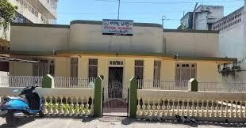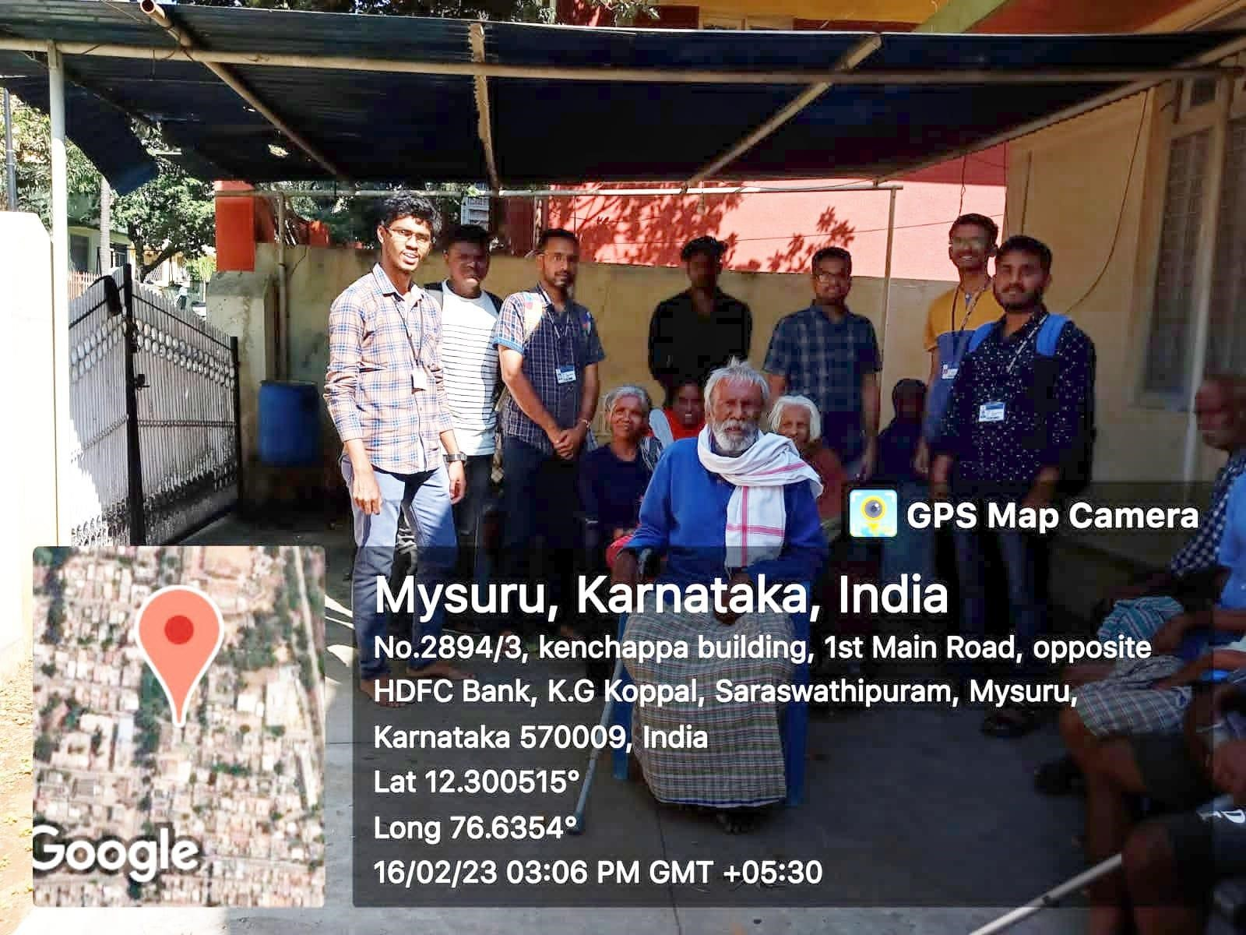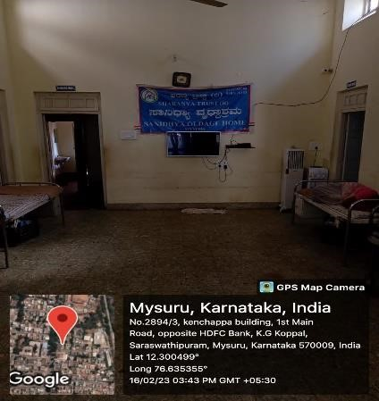

## INTRODUCTION

Old Age is a timeless ascent, as the power diminishes, one grows towards the light!

One cannot expect to stay young, shoulder responsibility, be a part of the change and watch the evolution. As everything progresses, the previous bygone are left behind for the new, and the same principle applies, unfortunately, even to human beings. One gets to enjoy a lifetime of decades, dealing with problems, solving everyday tasks and issues, facing tough challenges, and providing the best for everyone, from family to friends to workspaces and more. However, one cannot do this for eternity, it simply implies that after providing till the deed is done, it is simply a state to “pass the torch” and “carry-on”

As old age creeps into human life, it hampers every day, slowing them down, plaguing them with illnesses, body pain, deformations, suffering, and much more, this, however, cannot be handled by the youth of today, either out of commitments elsewhere or due to ungratefulness. Cases of old parents being killed by horrible-minded children and their counterparts for access of property, money or benefits, being abandoned in airports, railway stations or middle of highways with absolutely nothing have been reported aplenty in the newspapers. However, it is incorrect to bring out the negatives only. There are many good and well bought up children who under circumstances such as travel for work and being abroad for work, uncertainties in family, are left without choices, and have to set up alternatives for their old parents to be under supervision for their safety, well-being and protection. That is when old-age homes come into picture.

Old age homes are residences where senior citizens or old age people live with all the basic facilities and with proper care. They are designed keeping the requirement of aged seniors in mind by providing agespecific amenities. These homes provide nursing and care in a clinical setting. There are many reasons why old age homes are not dimmable by elders. The most prominent one is the thought that at an old age home, there is nobody like their children who would understand them and care for their unique needs. However, a roof over their heads is a critical need of the elder who are destitute, sick and abandoned by family and those uprooted by disasters.

Sanidhya Oldage Home located in K.G. Koppal, Mysore has been providing Home Nursing Services for the past 5 years. It provides well-trained & well-mannered nurses. They provide Home Nursing Services in Mysore. Their goal is to provide the best services at affordable prices to our esteemed guests. Their trained nurses help in taking care of the elders for their day-to-day activities. Their focus area is to provide an integrated approach to build an equitable and empowered society, with the mission to work towards developing and implementing activities that enhance productive aging. They will provide services that enable older adults to remain healthy, active, and empowered, constantly striving to be a leader in longterm care, to live & To enhance the quality of life of elders through innovative and comprehensive care with love and affection.

## Brief Information about the Activity

The activity was carried out for a period of two weeks, excluding the time taken to contact the authority of the old-age house.

On the first day of the visit, we interacted with the old inhabitants of the house. Interacting with older adults requires sensitivity and respect, as well as an understanding of the unique challenges and experiences that come with aging. We were patient and had to listen attentively; Older adults take longer to process information or express themselves, so it was important to be patient and allow them time to share their thoughts and feelings.

Listening attentively and showing genuine interest in what they had to say went a long way in building rapport and fostering trust. We were told a few stories about their past youth and working and were advised a lot. Some of the advice we took were to cherish relationships as one got older, one start to realize how important the people in your life are, staying active both physically and mentally, can help maintain health and independence, embrace change as life is full of changes, both big and small and with an open mind and a positive attitude, be willing to adapt and learn new things as you go and finally, pursue passions: do not let age stop pursuing your passions and trying new things. This was a very fruitful day, the advice we took was very valuable, we left content and promising we would return the next day. On the other days we interacted with the old citizens and learnt more about their days and we heard stories about how different things were in the day. We heard humorous stories about their children’s school days, a few stories about their families and their doings, a very nice memory about the radio, black and white movies, Dr. Rajkumar and more. We further interacted with them and played a few games of Carrom and Chess, they proving they haven’t lost much of their spunk and could beat us in the games of Carrom. We also helped to serve lunch for a few older people and assisted them to walk around the rooms, thus helping them in little ways and making them happy.

The people were interested to hear our stories and we were made to explain what was happening in our college life, what we study and how technologies have been achieving wonders. We tried to explain in simple language which highly fascinated them. We helped to demonstrate video calls through WhatsApp Video Call feature, and we watched one of the senior women speak with her daughter who was in another city. We also showed the seniors about digital payments and even demonstrated a transfer of money from one mobile account to another which was highly appreciated and alarmed a few of the seniors who couldn’t believe the possibilities of the idea. The day passed quickly and it was time for us to leave, we left with a smile, content with the trip, learning, advice and happiness of having spent a good amount of time productively.

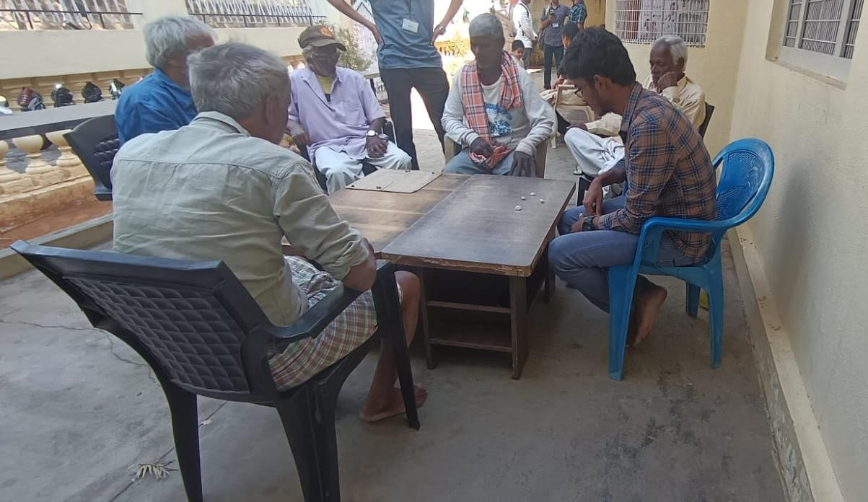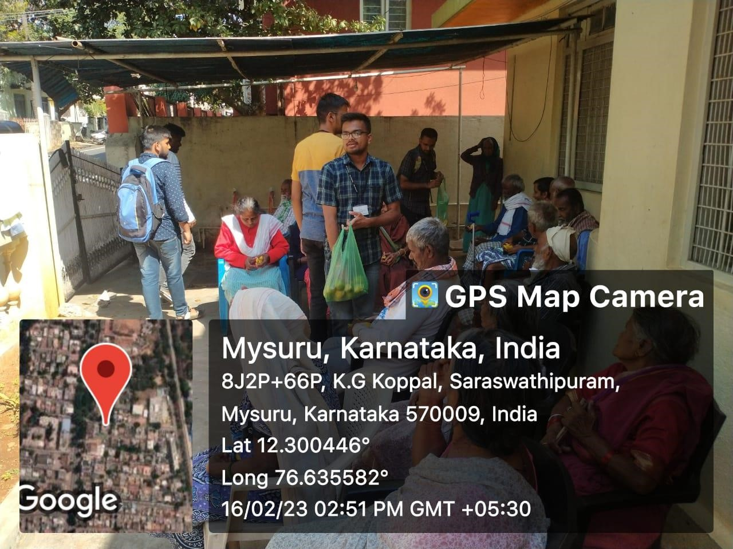**PHOTO GALLERY**

*Volunteers donating fruits & sweets to the old people*

**INTERACTION WITH OLD PEOPLE IN OLDAGE HOME**

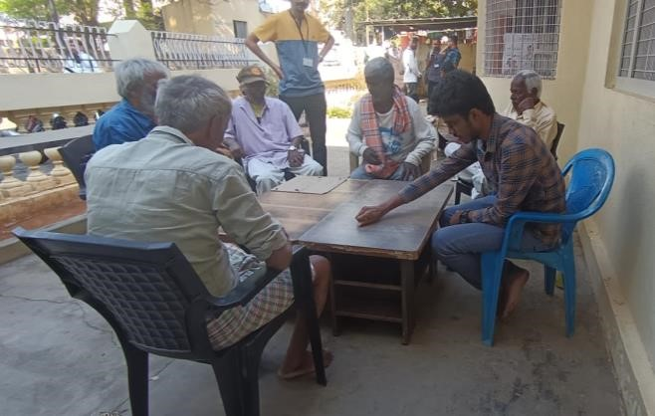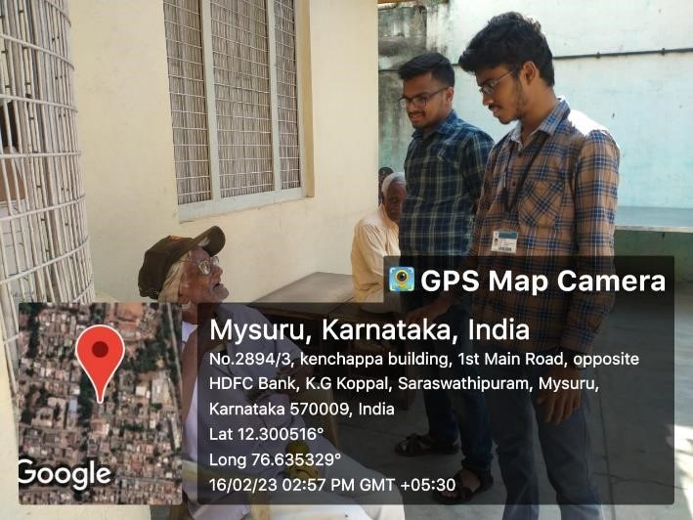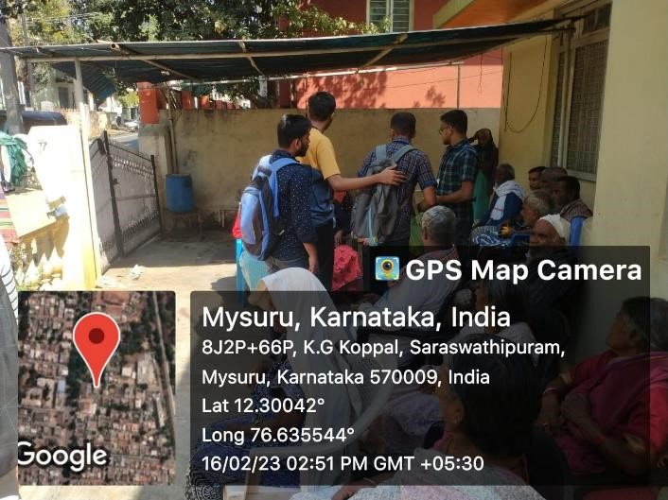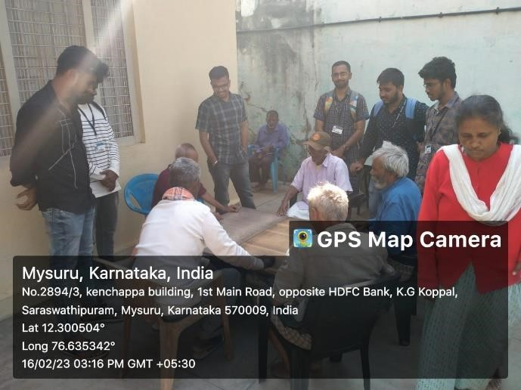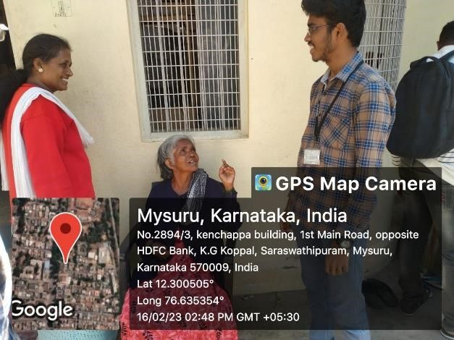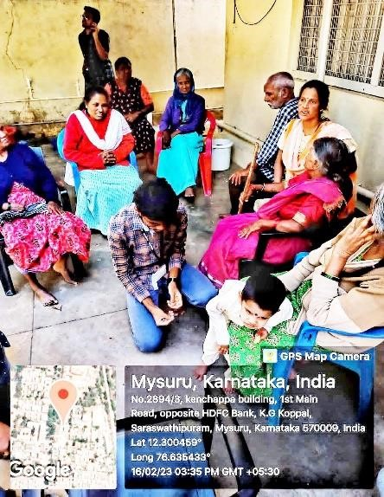

### CONCLUSION

The visit to the old age home was a life-changing experience that provided valuable insights into the challenges and experiences of aging. Here were a few key takeaways from our three-day visit to the old age home:

Aging is a difficult and emotional process, but it's important to remember that older adults still have a lot to offer and can make valuable contributions to our communities.

Interacting with older adults requires patience, empathy, and respect. It's important to listen attentively, use clear and simple language, and be mindful of physical limitations.

Self-care is important at any age, but it becomes even more critical as you get older. It's important to take care of your physical, mental, and emotional health in order to maintain your independence and quality of life.

Volunteering and giving back to your community can be a fulfilling way to connect with others and make a positive impact.

Overall, the visit to the old age home was a humbling and eye-opening experience that helped to broaden our perspective on aging and the human experience. It also inspired us to become a more compassionate and engaged member of the community.